# Finance Analysis of AtliQ Hardwares – P&L by Year Report Step-by-Step Process

## Excel Data Model

We already have the Excel file with the following data model:

* fact_sales_monthly
* dim_customer
* dim_product
* dim_market
* dim_date
* ns_targets_2021

## Using Power Query

* **Import** fact_sales_monthly_with_cost (CSV file).
* **Rename** the imported file as finance ref.
* **Reference** the already existing fact_sales_monthly to finance ref and rename it to fact_sales_monthly_with_cost.
* **Remove unwanted steps** in the query to keep only necessary transformations.
* **Group queries for easy access:**
  + dim_customer, dim_product, dim_market, dim_date grouped as **Dimension**.
  + fact_sales_monthly_with_cost, ns_targets_2021 grouped as **Fact**.
* **Close & Load** the queries.
* Since tables are already in the data model and the relationships exist, keep the **“Add to Data Model”** option unchecked.

**P&L by Year Report Mock-up View**

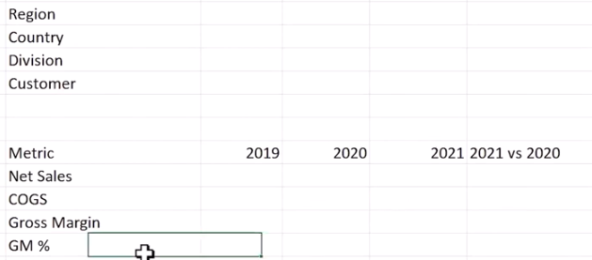

## Using Power Pivot

* In fact_sales_monthly_with_cost, we have:
  + freight_cost
  + manufacture_cost
* **Create a new column:**
  + Name: COGS (Cost Of Goods Sold)
  + Formula:

= [freight_cost] + [manufacture_cost]

## Create Measures for Metrics

1. **Total_net_sales**

= SUM([net_sales_amount])

1. **COGS**

= SUM([total_COGS])

1. **Gross Margin**

= [total_net_sales] – [COGS]

1. **GM %**

= DIVIDE([gross_margin], [total_net_sales], 0)

(Format as Percentage)

## Create Pivot Table

* Drag fiscal_year from dim_date to **Columns**.
* In **Values**, add:
  + Total_net_sales (custom name: Net Sales)
  + COGS
  + Gross Margin
  + GM %
* Drag **Measure Values** to **Rows**.

**Creating the "2021 vs 2020" Column**

Note:  
If you want to create this comparison directly in Power Pivot, you would need separate measures filtering each year, which takes more time.

**Faster alternative in Excel:**

* Use a formula directly in the worksheet:

=IFERROR((E10 – D10) / D10, "")

* Drag the formula down to apply it to all rows.

## Visualization & Formatting

* Apply **Conditional Formatting**:
  + Color scale to each row of metrics.
  + Data bar to the "2021 vs 2020" column for quick visual comparison.

# Finance Analysis of AtliQ Hardwares – P&L by Month Report Step-by-Step Proces

**P&L by Month Report Mock-up View**

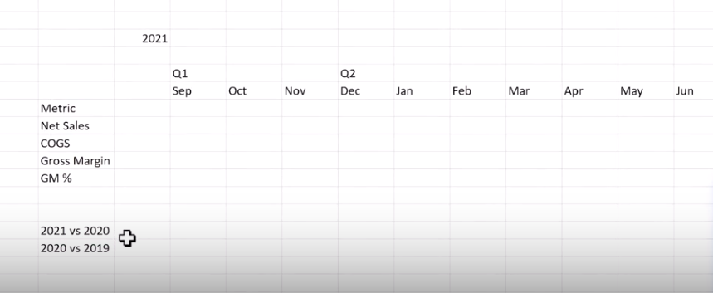

## Create Report Copy

Make a copy of the existing report:

* **Original Report Name:** P&L_by_Year
* **New Report Name:** P&L_by_Month

**Using Power Pivot**

**Add Month Column**

* Add a new column named **Month**.
* Formula:

= FORMAT([date], "MMM")

*(This extracts the month abbreviation, e.g., Jan, Feb, etc.)*

**Add Fiscal Month Number**

* Add a column named **fy_month_no**.
* Formula:

= MONTH(DATE(YEAR([date]), MONTH([date]) + 4, 1))

*(This shifts the month to align with the fiscal calendar.)*

**Add Quarter Column**

* Add a column named **Quarter**.
* Formula:

= "Q"&ROUNDUP(dim_date[fy_month_no]/3,0) *(This calculates the quarter number.)*

**Sort Month Column**

* Sort the **Month** column by **fy_month_no** so months appear in the correct order in the Pivot Table.

## Using Pivot Table

**Configure Fields**

* Remove unwanted fields from Filters.
* Add **fiscal_year** to Filters.
* Drag **Quarter** first and then **Month** to Columns.

**Create Year-Specific Views**

* Filter **fiscal_year** to **2019**.
* Copy the entire Pivot Table and paste it two more times.
* For each copied Pivot Table:
  + Set one filter to **2020**.
  + Set the other filter to **2021**.

## Year-over-Year Comparison Calculations

Calculate Net Sales comparisons as follows:

* **2021 vs 2020**
  + Formula:

= C39 / C25 – 1

Alternative form:(C39 – C25) / C25

* + Format the result as Percentage.
* **2020 vs 2019**
  + Formula:

= C25 / C11 – 1

Alternative form:(C25 – C11) / C11

* + Format the result as Percentage.

## Grand Totals

* Show **Grand Total** rows to summarize results across all months.

## Visualization and Formatting

* Apply **3-color scale conditional formatting** to all metric rows for better visualization. (Make use of format painter for doing this.)
* Use **different color scales** for:
  + **GM% rows**
  + **Net Sales comparison rows**

This helps make trends and variances clearer at a glance.